Salesforce Developer Bridge Program
Day 1 — Self-Learning Track Documentation
Name: Gunta Sai Koushik
Regd No: 23PA1A4544

Block 1: Data Model Refresh

Task 1 — Design a Mini Data Model
Data Model
A data model is the structure used to organize and manage data in Salesforce. It defines the objects, fields, and relationships between records so that information is stored efficiently and can be easily accessed.
Relationships
Relationships connect different objects in Salesforce.
- Lookup Relationship: A flexible connection where records can exist independently of each other.
- Master-Detail Relationship: A strong parent-child relationship where the child record depends on the parent, and deleting the parent also deletes the related child records.
Hospital OPD Data Model
For the Hospital OPD scenario, I created four custom objects:
- Patient
- Doctor
- Appointment
- Prescription
Relationships used:
- Patient → Appointment: Master-Detail, because every appointment must belong to a patient.
- Doctor → Appointment: Lookup, because a doctor can exist independently, and appointment history should be retained.
- Appointment → Prescription: Master-Detail, because a prescription is created only for a specific appointment.
Screenshot — Schema Builder (Object Manager)
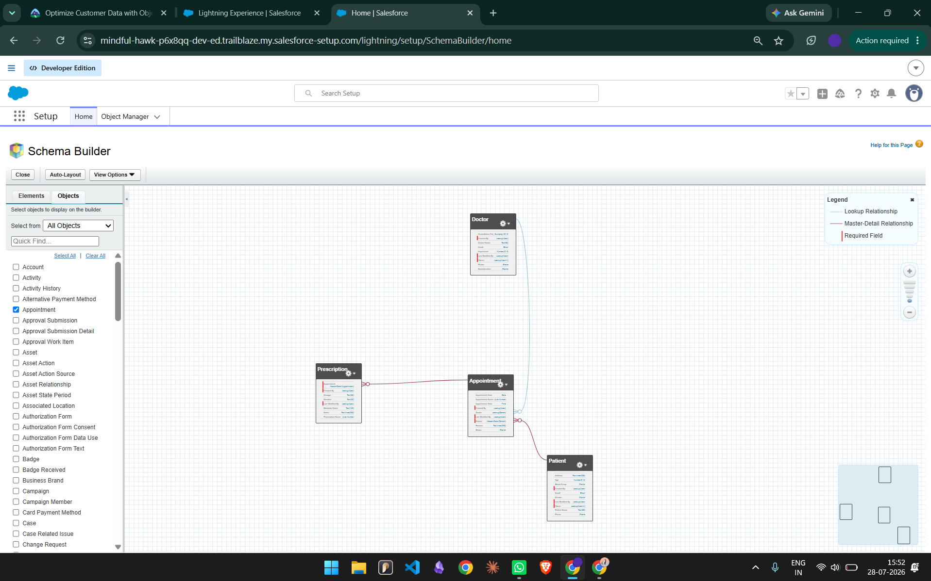

Block 2: Apex Basics — Classes, Variables, SOQL

Task 2 — Write it Yourself
Apex Basics
Apex is Salesforce's object-oriented programming language used to add custom business logic, automate processes, and interact with Salesforce data. It runs on the Salesforce platform and integrates seamlessly with database operations.
Classes
A class is a blueprint that contains variables and methods. It helps organize reusable code and implement application logic in a structured way. Basic example:
public class Patient {
// instance variables (fields)
public String name;
public Integer age;

// constructor
public Patient(String name, Integer age) {
this.name = name;
this.age = age;
}

// method
public String getSummary() {
return name + ' (' + age + ' yrs)';
}
}

Variables
Variables are used to store data in Apex. Each variable has a specific data type, such as String, Integer, Boolean, or Date, depending on the type of value it holds. Basic examples:
String patientName = 'Ananya Verma';
Integer patientAge = 26;
Boolean isScheduled = true;
Date appointmentDate = Date.today();
Decimal experienceYears = 12.5;

SOQL (Salesforce Object Query Language)
SOQL is used to retrieve records from Salesforce objects. It is similar to SQL but is designed specifically for querying Salesforce data and relationships. Basic examples:
// simple query
List<Account> accList = [SELECT Id, Name FROM Account];

// query with a filter
List<Appointment__c> apptList = [SELECT Id, Name, Status__c
FROM Appointment__c
WHERE Status__c = 'Scheduled'];

Task 3 — SOQL Practice
Using the Hospital OPD objects created in Task 1, sample records were added for Patients, Doctors, Appointments, and Prescriptions. Five SOQL queries were then written and executed to satisfy the WHERE, ORDER BY + LIMIT, relationship, aggregate, and comparison-operator requirements.
Sample Data Used
Patients
Ananya Verma — Age 26, Female, Blood Group B+
Vikram Singh — Age 35, Male, Blood Group O-
Meera Nair — Age 45, Female, Blood Group AB+
Doctors
Dr. Arjun Mehta — Orthopedic, 12 years experience
Dr. Divya Iyer — Gynecologist, 7 years experience
Dr. Suresh Rao — ENT Specialist, 9 years experience
Appointments
AP-1001 — Patient: Ananya Verma, Doctor: Dr. Arjun Mehta, Date: Today, Status: Scheduled, Reason: Knee Pain
AP-1002 — Patient: Vikram Singh, Doctor: Dr. Divya Iyer, Date: Tomorrow, Status: Completed, Reason: Routine Checkup
AP-1003 — Patient: Meera Nair, Doctor: Dr. Suresh Rao, Date: Day After Tomorrow, Status: Cancelled, Reason: Ear Infection
Prescriptions
AP-1002 (Completed) — Ibuprofen, 400 mg, 5 days
AP-1002 (Completed) — Multivitamin, 1 Tablet, 15 days
AP-1003 (Cancelled) — Azithromycin, 250 mg, 6 days

Query 1 — WHERE Clause
SELECT Name, Appointment_Date__c, Status__c
FROM Appointment__c
WHERE Status__c = 'Scheduled'

Output: AP-1001 — Scheduled
What happened: Only AP-1001 was returned because it is the only appointment whose Status__c equals 'Scheduled'; the WHERE clause filtered out the Completed and Cancelled records.
Query 2 — ORDER BY + LIMIT
SELECT Name, Appointment_Date__c
FROM Appointment__c
ORDER BY Appointment_Date__c DESC
LIMIT 2

Output: AP-1003, AP-1002
What happened: Records were sorted by Appointment_Date__c in descending order and then capped at 2 rows, so only the two appointments with the latest dates (AP-1003 and AP-1002) were returned; AP-1001 was left out.
Query 3 — Relationship Query (Child → Parent)
SELECT Name,
Patient__r.Name,
Doctor__r.Name,
Status__c
FROM Appointment__c

AP-1001 — Patient: Ananya Verma, Doctor: Dr. Arjun Mehta, Status: Scheduled
AP-1002 — Patient: Vikram Singh, Doctor: Dr. Divya Iyer, Status: Completed
AP-1003 — Patient: Meera Nair, Doctor: Dr. Suresh Rao, Status: Cancelled

What happened: The dot notation (Patient__r.Name, Doctor__r.Name) traversed the lookup and master-detail relationships from Appointment__c to its parent records, pulling the related Patient and Doctor names directly into the same result row without a separate query.
Query 4 — Aggregate Query
SELECT Status__c,
COUNT(Id)
FROM Appointment__c
GROUP BY Status__c

Scheduled — 1
Completed — 1
Cancelled — 1

What happened: GROUP BY collapsed the appointment records into one row per distinct Status__c value, and COUNT(Id) tallied how many records fell into each group — one appointment in each of the three statuses.
Query 5 — Comparison Operator (>=)
SELECT Name,
Experience__c
FROM Doctor__c
WHERE Experience__c >= 7

Dr. Arjun Mehta — 12
Dr. Suresh Rao — 9
Dr. Divya Iyer — 7

What happened: The >= operator kept every doctor with 7 or more years of experience; since all three doctors met that threshold, all three were returned, ordered as retrieved rather than by experience.
Result
All 5 SOQL queries executed successfully without any syntax errors, and each returned the expected output. The queries and their outputs were saved to a text file named Task3_SOQL_Practice.txt as part of the end-of-day submission.

Block 3: Apex Triggers

Task 4 — Appointment Automation (Trigger + Handler)
The submission for this task contains two Apex files: a trigger file and a handler class file. This follows the rule that a trigger should only call the handler, and all business logic should live inside the handler class.
Scenario
The Hospital OPD Management System manages patients, doctors, appointments, and prescriptions. For this task, automation was implemented using Apex Triggers on the Appointment__c object.
Business Requirements
Before Insert: Prevent duplicate appointments — a patient cannot have more than one appointment on the same date.
After Update: Whenever an appointment's status changes to Completed, automatically update the patient's Last Visit Date.

File 1 — AppointmentTrigger.trigger
trigger AppointmentTrigger on Appointment__c (before insert, after update) {

if (Trigger.isBefore && Trigger.isInsert) {
AppointmentTriggerHandler.preventDuplicateAppointments(Trigger.new);
}

if (Trigger.isAfter && Trigger.isUpdate) {
AppointmentTriggerHandler.updatePatientLastVisit(Trigger.new);
}

}

File 2 — AppointmentTriggerHandler.cls
public class AppointmentTriggerHandler {

// BEFORE INSERT — Prevent duplicate appointments
public static void preventDuplicateAppointments(List<Appointment__c> newAppointments) {

Set<Id> patientIds = new Set<Id>();
Set<Date> appointmentDates = new Set<Date>();

for (Appointment__c appt : newAppointments) {
if (appt.Patient__c != null) {
patientIds.add(appt.Patient__c);
}
if (appt.Appointment_Date__c != null) {
appointmentDates.add(appt.Appointment_Date__c);
}
}

List<Appointment__c> existingAppointments = [
SELECT Id, Patient__c, Appointment_Date__c
FROM Appointment__c
WHERE Patient__c IN :patientIds
AND Appointment_Date__c IN :appointmentDates
];

for (Appointment__c newAppt : newAppointments) {
for (Appointment__c oldAppt : existingAppointments) {
if (newAppt.Patient__c == oldAppt.Patient__c &&
newAppt.Appointment_Date__c == oldAppt.Appointment_Date__c) {
newAppt.addError('Duplicate appointment is not allowed for the same patient on the same date.');
}
}
}
}

// AFTER UPDATE — Update Patient Last Visit Date
public static void updatePatientLastVisit(List<Appointment__c> updatedAppointments) {

Map<Id, Date> patientVisitMap = new Map<Id, Date>();

for (Appointment__c appt : updatedAppointments) {
if (appt.Status__c == 'Completed' && appt.Patient__c != null) {
patientVisitMap.put(appt.Patient__c, appt.Appointment_Date__c);
}
}

if (patientVisitMap.isEmpty()) {
return;
}

List<Patient__c> patients = [
SELECT Id, Last_Visit_Date__c
FROM Patient__c
WHERE Id IN :patientVisitMap.keySet()
];

for (Patient__c p : patients) {
p.Last_Visit_Date__c = patientVisitMap.get(p.Id);
}

update patients;
}
}

Additional Field Required
Patient object — Field Label: Last Visit Date, API Name: Last_Visit_Date__c, Data Type: Date

Test Case 1 — Duplicate Appointment
Existing record: Rahul Sharma, Date = Today
Attempted new record: Rahul Sharma, Date = Today (same date)
Output: Duplicate appointment is not allowed for the same patient on the same date.
What happened: The before-insert handler queried existing appointments for the same patient and date before the new record was saved, matched the incoming record against that set, and blocked the save with addError() — so no duplicate row was ever created.
Test Case 2 — Update Appointment
Change made: Status changed from Scheduled to Completed on an existing appointment.
Output: The related Patient record's Last Visit Date was updated automatically to match the appointment date.
What happened: The after-update handler checked every updated appointment for Status__c = 'Completed', built a map of Patient Id to appointment date, queried the matching Patient records, set Last_Visit_Date__c on each, and saved them with a single update statement.
Note: screenshots of the duplicate-appointment error and the updated Last Visit Date are to be attached separately as part of the submission.
What I Learned About Triggers
Working through this task made the trigger-handler pattern click. A few things stood out:
- Keep triggers thin: the trigger file itself should only decide which context it's in (before/after, insert/update) and hand off to the handler — it shouldn't contain any actual logic.
- Bulkify everything: since a trigger can fire on a batch of up to 200 records at once, looping over Trigger.new and collecting Ids/dates into Sets before querying avoids running a query per record.
- One query outside the loop: both handler methods query the database once (existing appointments, or patients) using IN-bound Set/Map keys, instead of querying inside a for-loop — this is what keeps the trigger from hitting governor limits.
- addError() vs DML errors: calling addError() on a record inside a before-insert context stops that specific record from saving and surfaces a clean message to the user, without needing a manual DML call or try/catch.
- Maps make cross-object updates easy: using a Map<Id, Date> to pair each patient with their latest completed-appointment date made it simple to update only the relevant patient records in one batch DML call.
- Trigger context checks (Trigger.isBefore/isAfter/isInsert/isUpdate) let a single trigger handle multiple events cleanly by routing each to its own handler method.

Task 5 – Build One Simple LWC (Lightning Web Component)
Project Demo
📁 Google Drive:
https://drive.google.com/file/d/1H3zgPIG3seouEW1MqEkwWZzqwzgmWIcn/view?usp=sharing

What is LWC?
Lightning Web Components (LWC) is Salesforce's modern UI framework used to build fast, reusable, and responsive components using HTML, JavaScript, and CSS. LWC follows web standards and integrates seamlessly with Salesforce data through Apex and the Lightning framework.
Advantages
- Fast and lightweight
- Reusable components
- Uses standard JavaScript
- Easy integration with Apex
- Responsive Salesforce UI
- Better performance than Aura Components

Component Overview
Component Name: patientList
Purpose:
Displays Patient records stored in the custom Patient__c object by fetching data from Salesforce using the @wire service and displaying it inside a Lightning Card.

Architecture / Data Flow
Patient__c (Custom Object)
│
▼
PatientController.getPatients()
(Apex + SOQL)
│
▼
@wire(getPatients)
(patientList.js)
│
▼
patientList.html
(Display Patient Records)

Files Used
1. patientList.html
Responsible for the User Interface.
Functions:
- Displays Patient records in a table.
- Uses SLDS styling.
- Shows Loading spinner while data loads.
- Displays Error message if Apex fails.
- Displays "No patient records found" when no data exists.
- Uses lightning-card for Salesforce UI.

2. patientList.js
Responsible for Component Logic.
Functions:
- Imports Apex method getPatients.
- Uses @wire to fetch records automatically.
- Handles Loading, Error and Success states.
- Uses getter methods for cleaner code.
- Returns patient data to HTML.

3. patientList.js-meta.xml
Component Configuration File.
Functions:
- Makes component available in Lightning App Builder.
- Allows adding component to:
  - Home Page
  - App Page
  - Record Page
- Restricts Record Page usage to Patient__c object.

Patient Fields Displayed
Field | API Name
Name | Name
Age | Age__c
Gender | Gender__c
Phone | Phone__c
Additional fields fetched from SOQL
- Email__c
- Blood_Group__c
- Address__c
These fields are retrieved but currently not displayed in the UI.

Component States
State | Description
Loading | Spinner is displayed while records are being fetched.
Success | Patient records are displayed in the table.
Error | Error message is shown if Apex execution fails.
Empty | "No patient records found" is displayed when there are no records.

Key LWC Concepts Used
@wire
Automatically calls the Apex method and retrieves data without manually invoking Apex.

Apex Controller
The component communicates with an Apex class (PatientController) that executes a SOQL query and returns Patient records.

SOQL
Used to retrieve records from the custom Patient__c object.

cacheable=true
Caches the response to improve performance and reduce unnecessary server calls.

for:each
Loops through the patient list and generates one table row for each record.

if:true
Used for conditional rendering such as Loading, Error, Success, and Empty states.

SLDS (Salesforce Lightning Design System)
Provides Salesforce's standard styling, responsive layout, and consistent user experience.

Expected Result
- LWC successfully deployed.
- Component added to Lightning App Builder.
- Patient records displayed from the custom object.
- Loading, Error, and Empty states handled properly.
- Uses Apex, SOQL, and @wire for real-time data retrieval.

Learning Outcome
By completing this task, I learned:
- How to create a Lightning Web Component.
- How to connect LWC with Apex using @wire.
- How to fetch Salesforce records using SOQL.
- How to display data dynamically in an SLDS-styled table.
- How to handle Loading, Error, Success, and Empty UI states.
- How to expose an LWC in Lightning App Builder for Home, App, and Record pages.

